Scientific Computing

MATH6183001

**ODE = Ordinary Differential Equations**

An ordinary differential equation (ODE) is an equation that involves some ordinary derivatives of a function.

There are several methods:

1. Taylor Series Method

2. Euler’s Method = 1st order Runge-Kutta method

3. 2nd Order Runge-Kutta method

4. 4th Order Runge-Kutta method

**1. Taylor Series Method**

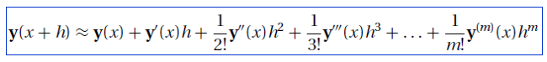

Truncation error:

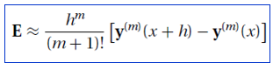

Ex:

Given y’ + 4y = x2, y(0)=1, h=0.1.

a. Prove that y = $\frac{31}{32}e^{-4x}+\frac{1}{4}x^{2}-\frac{1}{8}x+\frac{1}{32}$ is the solution of the ODE.

b. Estimate y(0.1) using Taylor 4th order, 6 d.p.

c. Find the truncation error

d. Find the actual error = yexact - yapprox

**2. Euler’s Method = 1st order Runge-Kutta method**

Iteration yn+1 = yn + h.F(x,y)

Ex: y’ = x + 2y, y(2) = 3. Estimate y(2.5) using Euler’s method h = 0.1 and 5 d.p.

**3. 2nd order Runge-Kutta method**

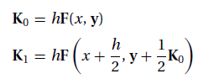



Ex: y’ = x + 2y, y(2) = 3. Estimate y(2.5) using 2nd Runge-Kutta method h = 0.1 and 5 d.p.

**4. 4th order Runge-Kutta method**

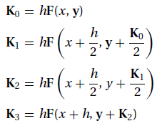



Ex: y’ = x + 2y, y(2) = 3. Estimate y(2.5) using 4th Runge-Kutta method h = 0.1 and 5 d.p.

**Numerical Error and Instability**

Accuracy = to get close to the exact solution.

Stability = to keep the error from growing.